Created by: Supported by:

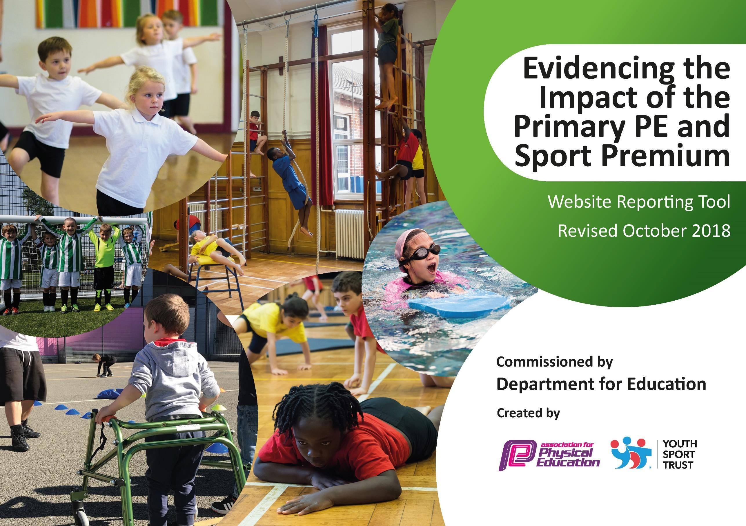

Schools must use the funding to make **additional and sustainable** improvements to the quality of Physical Education, Sport and Physical Activity (PESPA) they offer. This means that you should use the Primary PE and Sport Premium to:

Created by: Supported by:

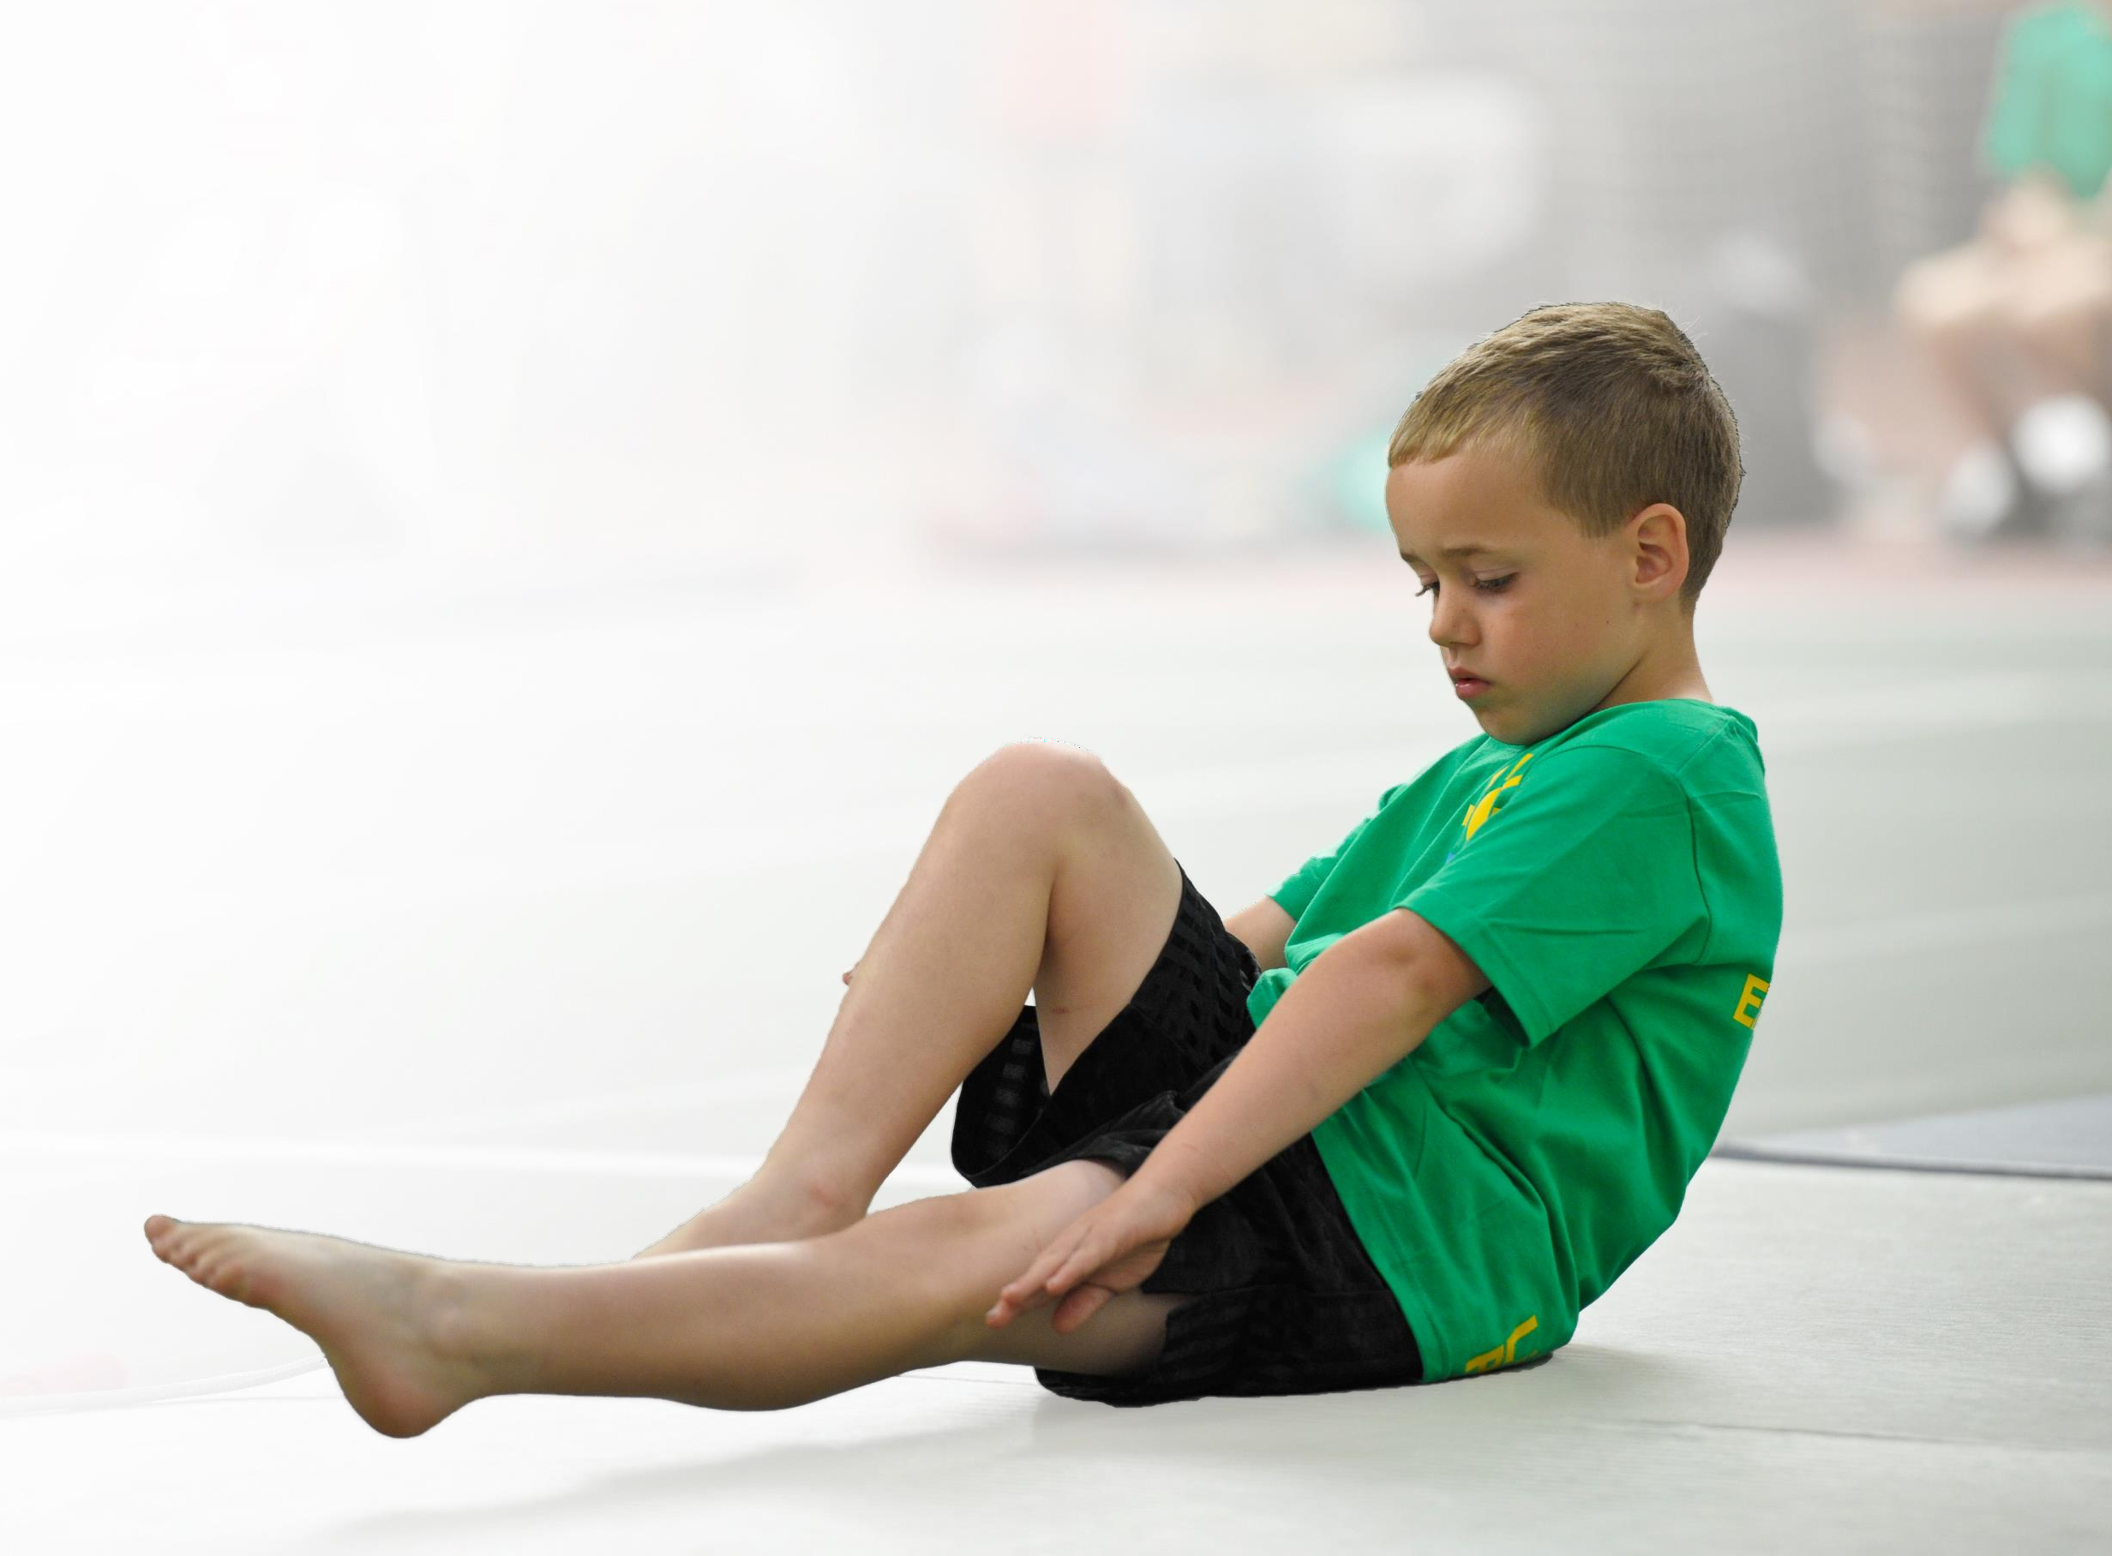

* Develop or add to the PESPA activities that your school already offer
* Build capacity and capability within the school to ensure that improvements made now will benefit pupils joining the school in future years

Please visit [gov.uk](https://www.gov.uk/guidance/pe-and-sport-premium-for-primary-schools) for the revised DfE guidance including the 5 key indicators across which schools should demonstrate an improvement. This document will help you to review your provision and to report

your spend. DfE encourages schools to use this template as an effective way of meeting the reporting requirements of the Primary PE and Sport Premium.

We recommend you start by reflecting on the impact of current provision and reviewing the previous

spend. Under the [Ofsted Schools Inspection Framework](https://www.gov.uk/government/publications/school-inspection-handbook-from-september-2015), inspectors will assess how effectively leaders use the Primary PE and Sport Premium and measure its impact on outcomes for pupils, and how effectively [governors](https://www.gov.uk/government/publications/governance-handbook) hold them to account for this.

Schools are required to [publish details](https://www.gov.uk/guidance/what-maintained-schools-must-publish-online#pe-and-sport-premium-for-primary-schools) of how they spend this funding as well as on the impact it has on pupils’ PE and sport participation and attainment by the end of the summer term or by **31 July 2019** at the latest.

We recommend regularly updating the table and publishing it on your website throughout the year, as evidence of your ongoing review into how you are using the money to

secure maximum, sustainable impact. To see an example of how to complete the table please click [HERE.](http://www.afpe.org.uk/physical-education/wp-content/uploads/afPE-Example-Template-Indicator-2018-Final.pdf)



Support for review and reflection - considering the 5 key indicators from DfE, what development needs are a priority for your setting and your

students now and why? Use the space below to reflect on previous spend, identify current need and priorities for the future.

|  |  |
| --- | --- |
| Key achievements to date: | Areas for further improvement and baseline evidence of need: |
| 1. ***There have been more opportunities for pupils to represent Fleetdown Primary School in a variety of competition organised by the DDPSSA.*** 2. ***Year 5 &6 pupils have enjoyed the new lunchtime sports activities provided by All Star Sports. As a result, pupils have asked for more sporting opportunities to be made available at lunchtime.*** 3. ***The introduction of Play Leaders has been very successful. They are visible and help children keep active at lunchtimes.*** 4. ***More children are attending after school sports clubs from the previous academic year (170 currently attend a variety of sports clubs).*** 5. ***The number of Pupil Premium pupils attending sports clubs has increased by 19% compared to Term 3 in 2019***   ***Ofsted Sports Grant visit in September 2018 was very successful.*** | * ***Increased confidence, knowledge and skills of all staff in teaching PE (KI3)*** * ***KS2 pupils have the opportunity to visit sporting events/locations e.g Olympic park to be inspired to take up sport or attend a sporting event etc…(KI4)*** |

|  |  |
| --- | --- |
| Meeting national curriculum requirements for swimming and water safety | Please complete all of the below: |
| What percentage of your current Year 6 cohort swim competently, confidently and proficiently over a distance of at least 25 metres?  **N.B.** Even though your children may swim in another year please report on their attainment on leaving primary school. | % |
| What percentage of your current Year 6 cohort use a range of strokes effectively [for example, front crawl, backstroke and breaststroke]? | % |
| What percentage of your current Year 6 cohort perform safe self-rescue in different water-based situations? | % |
| Schools can choose to use the Primary PE and Sport Premium to provide additional provision for swimming but this must be for activity **over and above** the national curriculum requirements. Have you used it in this way? | Yes, children that didn’t meet the NC requirements in Year 4 are provided with extra swimming opportunities in Year 6. |



**Action Plan and Budget Tracking**

Capture your intended annual spend against the 5 key indicators. Clarify the success criteria and

evidence of impact that you intend to measure to evaluate for students today and for the future.

|  |  |  |  |  |
| --- | --- | --- | --- | --- |
| **Academic Year:** 2019/20 | **Total fund allocated:** £21,410 | **Date Updated:** | |  |
| **Key indicator 1:** The engagement of all pupils in regular physical activity – Chief Medical Officer guidelines recommend that primary school children undertake at least 30 minutes of physical activity a day in school | | | | Percentage of total allocation: |
| % |
| School focus with clarity on intended **impact on pupils**: | Actions to achieve: | Funding allocated: | Evidence and impact: | Sustainability and suggested next steps: |
| Daily Mile – ALL children to take part in the Daily Mile, this will ensure that they complete 10min of walking/running each day. | Timetable slots for each year group to partake in the Daily Mile. | FREE | PE leaders to photograph Daily Mile in action, Pupil Voice. | PE leader has contacted Mel Harding (Daily Mile co-ordinator) to discuss the best way to implement the scheme. A pupil voice survey carried out in Term 3 showed that 80% of the children want to take part in the Daily Mile. |
| Play Leaders – encourage games and use of sport equipment during lunch break ensuring children are being active. To order more play equipment for children to use a break/lunch times. | Year 6 Play Leaders actively promote physical activity by leading lunchtime games for EYFS, KS1 and KS2pupils. | £278.75 – new play equipment for the playground  £390.72 – training Play Leaders | PE leaders to ensure that this happens by monitoring both playgrounds during lunchtime.  Pupil voice survey in Term 3 showed that 50% of KS1 children join in with the activities whilst only 6% of KS2 children. | Promote the Play Leaders during an assembly to encourage more children to participate. Ask children across both Key Stages what type of games they would like to have on offer. |
| Sports coaches used to promote physical activity during lunchtime and at Treasure Chest (after school club). | *All Star* Sports coaches lead two lunchtime sports sessions in KS2 playground, four times a week.  X2 All Star Sports coaches to be employed Mon-Fri to run daily sports sessions at Treasure Chest.. | £320.00 per month  £700 per month | Photographic/video evidence, pupil voice  Observations carried out show that the children are engaged with the sports coaches and enjoy the sporting activities on offer. Pupil voice survey carried out in Term 3 show that 50% of the KS1 children join in with the play leaders. This is helping children to achieve the 60 minutes of physical activity each day. | Sports coaches to train TC staff so they know a variety of games/activities to do.    Sports Grant pays for one Sports coach for Treasure Chest club. |
| **Key indicator 2:** The profile of PE and sport being raised across the school as a tool for whole school improvement | | | | Percentage of total allocation: |
| % |

|  |  |  |  |  |
| --- | --- | --- | --- | --- |
| School focus with clarity on intended **impact on pupils**: | Actions to achieve: | Funding allocated: | Evidence and impact: | Sustainability and suggested next steps: |
| Provide KS2 pupils with a specialist dance teacher. | Book specialist dance teacher. | £30 per hour for Kay Walker & Carys-Mari Hedges to teach dance to each class (£1695.00 in total). |  |  |
| Inspire pupils’ love of PE and sport by asking an established sportsperson to visit the school. | Organise for a Team GB athlete to come in and deliver assemblies/sport sessions. | Cost? TBA | Due to Covid19 we have been unable to organise. |
| Children in KS2 to take part in District Sports. | Arrange District Sport Competition for 16 local schools to take part in track and field events. | Cost of medals? this cost is reimbursed by the DDSPPA | Due to Covid19 we have been  to organise. |
| Celebrate staff and children’s love of sport and achievements. | Ensure PE display boards in KS1/2 are kept up to date.  Sporting certificates/medals to be handed out in assemblies.  PE leader to create termly sports newsletter. | FREE | Photos of the display boards are evidenced in the PE subject leader’s folder. Pupils sporting achievements are celebrated in assemblies and at the end of each term, a sporting newsletter is emailed to all parents. |

|  |  |  |  |  |
| --- | --- | --- | --- | --- |
| **Key indicator 3:** Increased confidence, knowledge and skills of all staff in teaching PE and sport | | | | Percentage of total allocation: |
| % |
| School focus with clarity on intended  **impact on pupils**: | Actions to achieve: | Funding  allocated: | Evidence and impact: | Sustainability and suggested  next steps: |
| Subject Leaders to undertake further | Subject leaders to attend PE conferences/courses.  All stars to provide CPD opportunities  PE leaders to carry out PE lesson observations | £250 – online resource | Both PE leaders attended a conference held by Green Acres, following this we purchased the online version of the scheme of work so all teachers have access to it via the One Drive, this enables them to upload end of term assessments and adapt lesson plans.  This has not been organised due to Covid 19 |  |
| training in order to up-skill their own |  |
| knowledge and understanding so they |  |
| can confidently disseminate to all staff, |  |
| thus increasing their knowledge and |  |
| confidence. |  |
| Staff meeting slot allocated to PE training. | FREE |
| Children to receive good PE lessons | FREE |
| **Key indicator 4:** Broader experience of a range of sports and activities offered to all pupils | | | | Percentage of total allocation: |
| % |
| School focus with clarity on intended  **impact on pupils:** | Actions to achieve: | Funding  allocated: | Evidence and impact: | Sustainability and suggested  next steps: |
| Expose pupils to unusual sports through their PE lessons.  Ensure there is a wide range of after school sports clubs for children to join. | Organise for an Olympic fencing athlete to come in and deliver fencing lessons to pupils in Year 5 and 6 during terms 2 and 4.  PE leader to arrange for All Stars and outside companies to run after school sports clubs. (Football, netball, dance, fencing, yoga, tennis, archery, athletics). Pupil Premium children will be offered these clubs free of charge. | £3240.00  FREE – parents pay direct.  PP funding pays for PP chn to attend after school sports clubs. | Pupils have enjoyed learning a new sport that they haven’t been exposed to before. Pupil voice – 100% of chn enjoyed learning this sport.  There has been an increase of the amount of children attending after school sports clubs, there are currently 170 for term 3, compared to this time last year there has been a 4% increase but a 19% increase of PP children who attend. | Fencing after school club: this will allow those chn who have already learnt fencing skills during their PE lessons to practise them after school and will enable other year groups to learn a new sport. |

|  |  |  |  |  |
| --- | --- | --- | --- | --- |
| Pupils have the opportunity to visit secondary schools to try a range of different sports e.g. trampoline.  KS2 pupils have the opportunity to visit sporting events/locations e.g Olympic park to be inspired to take up sport or attend a sporting event etc…  Invite pupils and parents to attend a Don’t sit get fit session to target those that are overweight or unhealthy through diet and exercise. | Dartford FC to run an after school club too as part of their package.  Liaise with local secondary schools.  Find suitable event for children to attend.  PE Leader to organise for another Don’t Sit Get Fit session with KCC for the Autumn Term. | Inc in membership fee.  This program is no longer running. Instead skip2bfit would have been coming in Term 5 to deliver a workshop and assembly. | Football in Term 5.  Could not action due to Covid 19  Could not action due to Covid 19  Had to cancel due to Covid 19 |  |
| **Key indicator 5:** Increased participation in competitive sport | | | | Percentage of total allocation: |
| % |
| School focus with clarity on intended  **impact on pupils**: | Actions to achieve: | Funding  allocated: | Evidence and impact: | Sustainability and suggested  next steps: |
| Provide children with opportunities to take part in intra school football matches/tournaments for both KS1 and KS2.  Provide children with opportunities to take part in intra school netball, hockey, cross country, BOCCIA, tag rugby, infant agility, Futsal, sports hall athletics, kwik cricket  matches/tournaments for KS2 and | Affiliate with Dartford FC so we can enter their football tournaments and league games.  Attend DDPSSA meetings, keep in touch with Jon Rye to enter Fleetdown. | £1800  £75 DDPSSA  membership | Football matches have been played against other schools and the girls’ team have made it through to the next round.  We have entered a range of tournaments, SEN children have taken part in the Boccia competition and children from KS2 have had the opportunity to compete in netball and Futsal tournaments. Children in KS1 have enjoyed the Fast 5s soccer tournament and the Infant Agility tournament. |  |

|  |  |  |  |  |
| --- | --- | --- | --- | --- |
| KS2 children.  Celebrate Children’s success with termly sports newsletter | Arrange transport to and from sporting venues.  PE leader to create termly newsletter. | £580.00  FREE | Providing transport has meant we have been able to take part in intra school competitions.  At the end of each term, a sports newsletter celebrating the children’s sporting achievements has been sent home to parents, this has helped to develop parent communication and to promote sport across Fleetdown. | Could parents take their own children/car share to sporting events? |